# DAD 220 Cardinality and Targeted Data Template

1. **Retrieve employee tuples and identify the number of employees** in San Francisco and New York.

* Command for San Francisco: select firstName, lastName, jobTitle, offices.city from employees inner join offices on employees.officeCode = offices.officeCode where state = 'CA'.

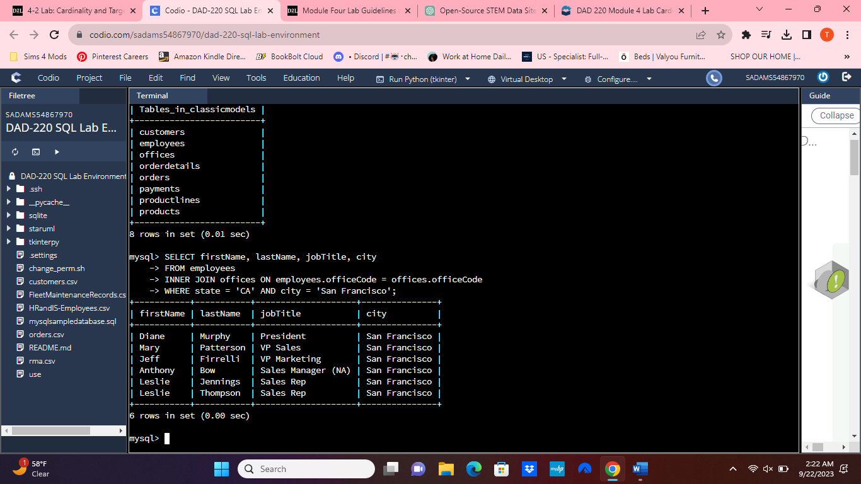

* Write and run a command to return records from New York on your own.

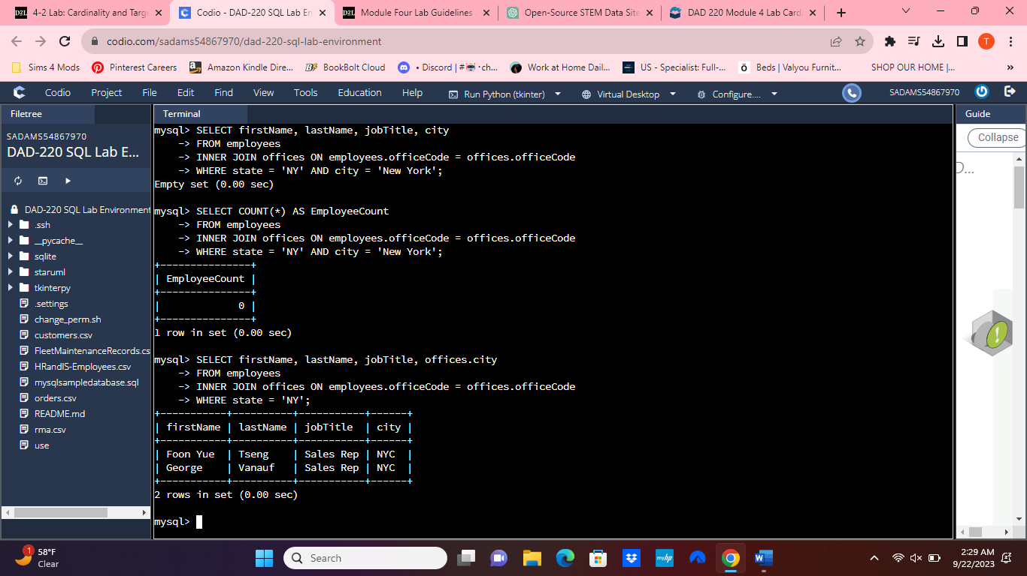

1. **Retrieve order details** for orderNumber 10330, 10338, and 10194 and **identify** what **type of cardinality** this represents in the entity relationship model.
   * Retrieve the order details by running SELECT queries with WHERE clauses against the orders table.
   * Then, reference the Module Four Lab ERD to assist in identifying relationships. A version with alternative text is available: [Module Four Lab ERD With Alternative Text](https://learn.snhu.edu/content/enforced/1398301-DAD-220-H7740-OL-TRAD-UG.23EW1/course_documents/DAD%20220%20Module%20Four%20Lab%20ERD%20With%20Alternative%20Text.docx?_&d2lSessionVal=Skcp2nRy8FlgzEDRT5usyk4q1&ou=1332080&_&d2lSessionVal=5PVZsKenHNWP277axx4fD52At&ou=1398301).
   * Now, identify what type of cardinality this represents in the entity relationship model.

* one-to-one cardinality, where each order number uniquely identifies one order.

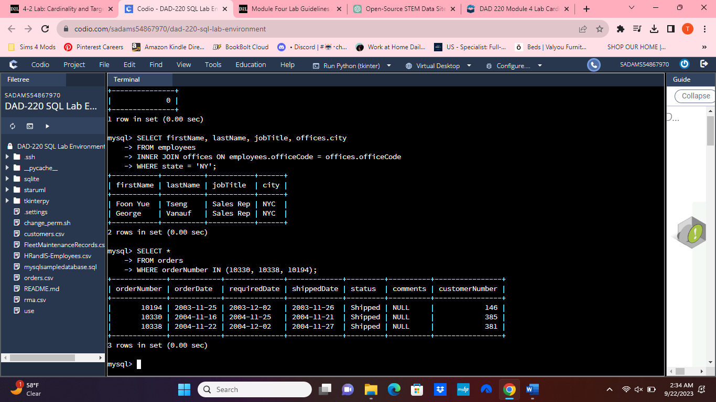

1. **Delete records** from the payments table where the customer number equals 103.
   * Run a DESCRIBE statement to identify fields in the payments table first.

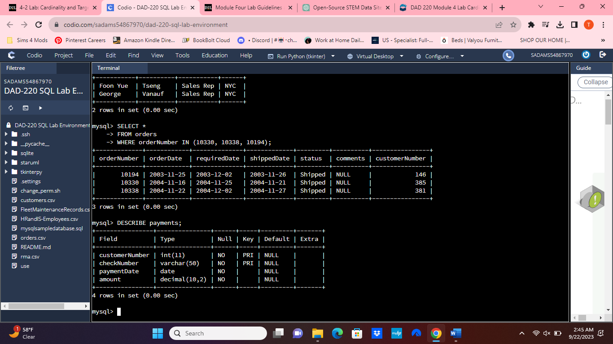

* + Select the records from the payments table for customer number 103 before deleting them
  + Delete the records from the payments table for customer number 103.
  + Run a SELECT statement against the table to show that customer number 103 is no longer there.

1. **Retrieve customer records** for sales representative Barry Jones and **identify** if the **relationships** are one-to-one or one-to-many**.**
   * Remember: SELECT, FROM, Inner Join, and WHERE.
   * Use Barry’s employeeNumber, 1504, and perform a join between the customer salesRepEmployeeNumber to retrieve these records

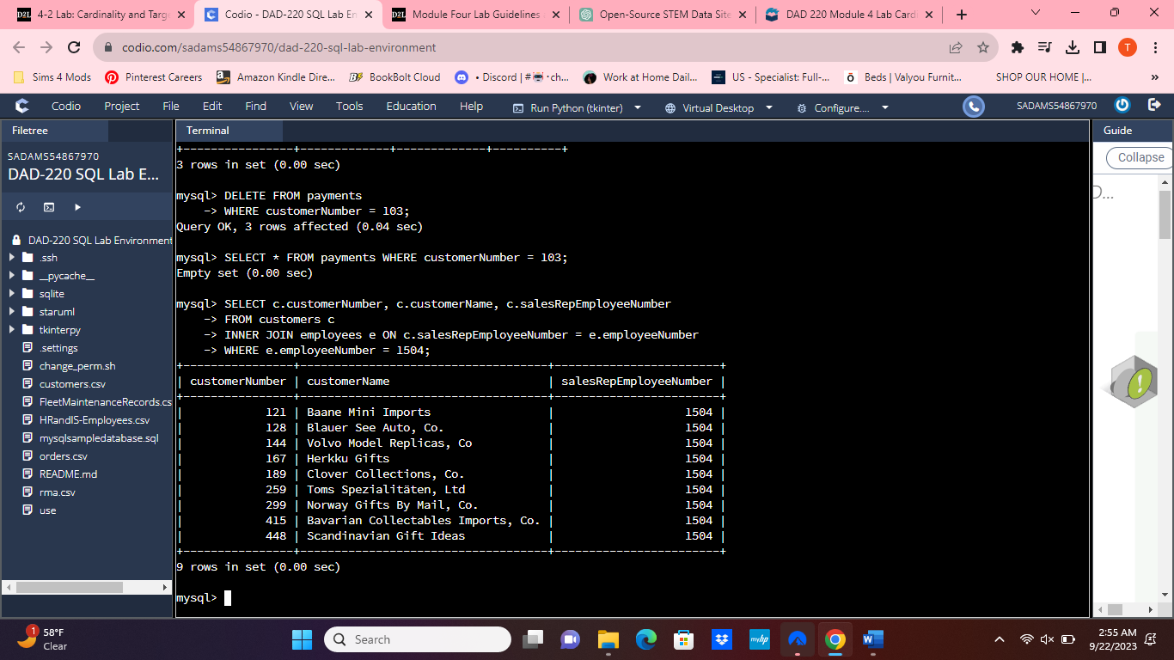

* + Identify whether these entities demonstrate one-to-one or one-to-manyrelationships.
* The relationships are one-to-many.

1. **Retrieve records** for customers who reside in Massachusetts and **identify** **their sales rep and the relationship of entities**. Identify if these entities demonstrate one-to-one or many-to-many relationships.
   * Remember: SELECT, FROM, Inner Join, and WHERE.
   * Use employee.firstName and employee.lastName in your command.

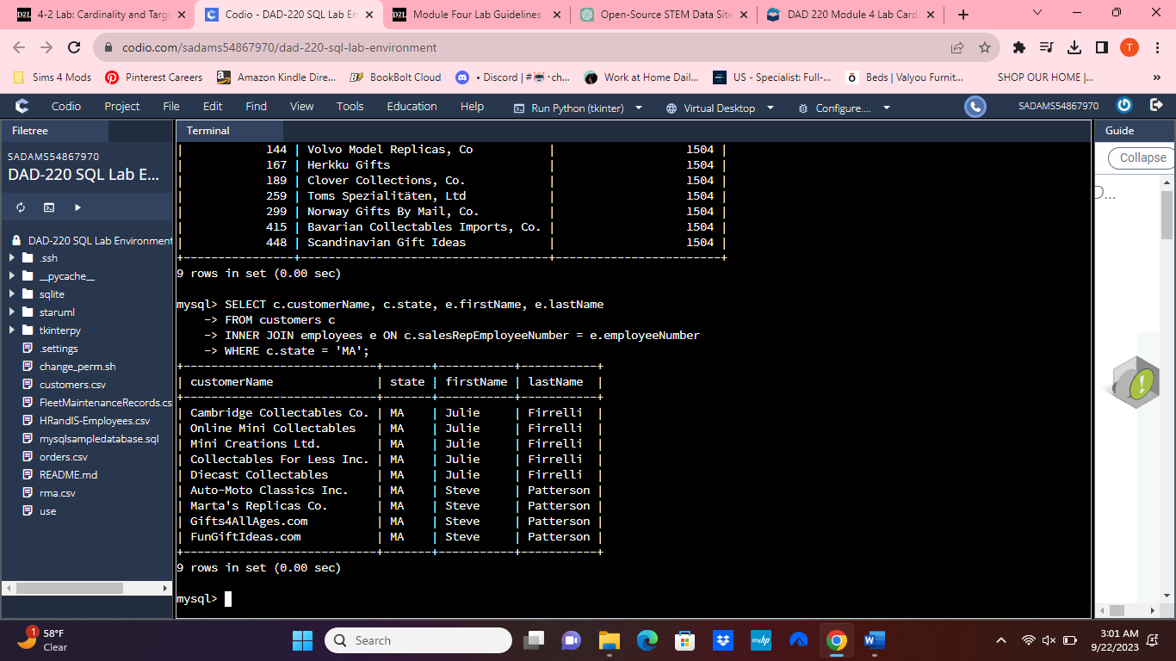

* + Identify whether these entities demonstrate one-to-one or many-to-many relationships**.**
* The relationships are one-to-many.

1. **Add one customer record** with your last name using an INSERT statement. You may use the name of a celebrity or fictional character if you don’t use your own name.
   * Complete these actions to get to the right place to enter this information: (1) Show databases, (2) use classicmodels, (3) show tables, (4) describe customers;

* You should now be seeing all of the fields that you’ll need to fill in to complete this step.
* Fields you’ll need to populate: customerNumber, customerName, contactLastName, contactFirstName, phone, addressLine1, addressLine2, city, state, postalCode, country, salesRepEmployeeNumber, and creditLimit.

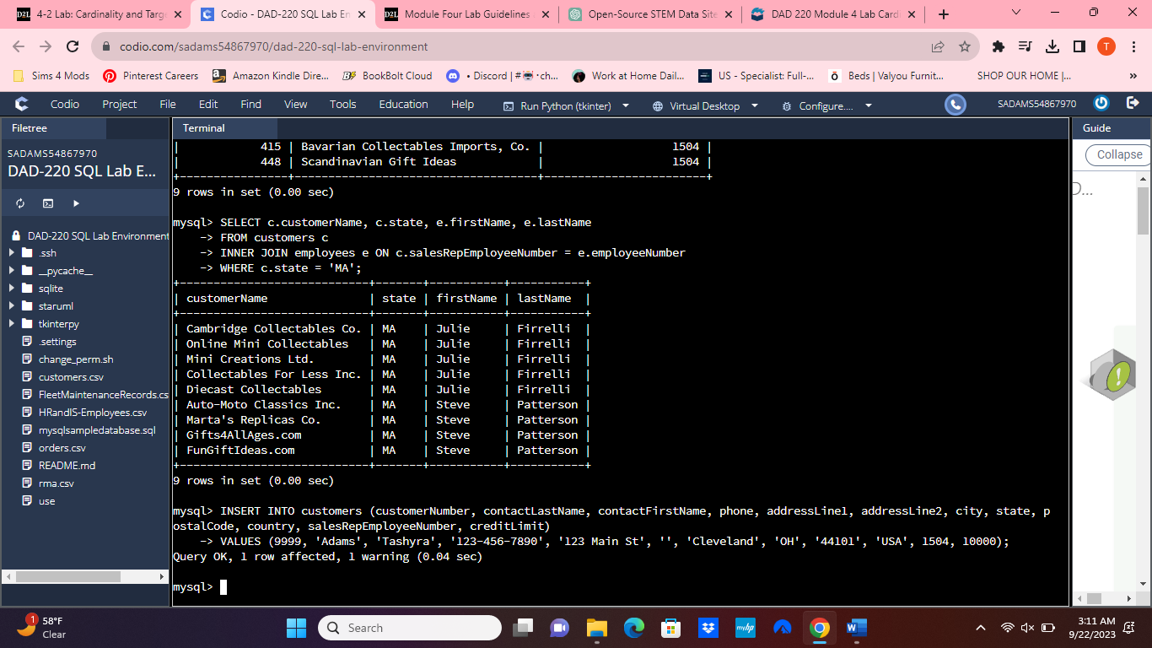

* Run a SELECT statement on the customers table, capture it in a screenshot, and put it in your template.

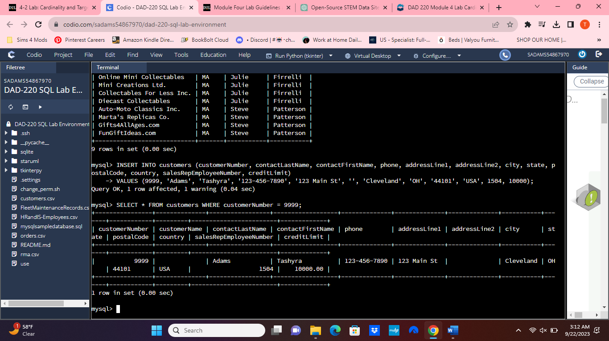

1. **Reflection**
   1. **Define how cardinality is applied** to the databases you’ve been working with and why different numbers of records returned from the different offices.

* Cardinality plays a crucial role in ensuring the accuracy of the relationships within the database. The presence of one-to-many relationships explains why we obtained distinct records from various offices.
  1. **Compare and contrast** the different **queries** you ran and how cardinality applies to them.
* Due to differences in the table data, cardinality leverages the corresponding information or connections among the data elements (such as products and order numbers) and can contrast this data with that of customers and employees (including salesRepEmployeeNumber, customerNumber, and employeeNumber).
  1. **Describe two** of the crucial **benefits** **of cardinality** in this type of database.
* One advantage is the capacity to issue a command specifying particular sales representatives to identify their respective customers. Another merit lies in the capability to juxtapose and merge diverse tables in order to extract the desired data.